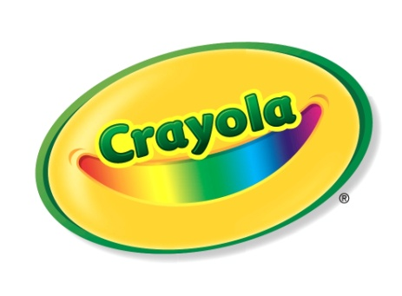**For Immediate Release**

Beth Gallant / Crayola

(610) 253-6272, ext. 4356

[BGallant@crayola.com](mailto:BGallant@crayola.com)

Alli Matteo / Coyne PR

(973) 588-2232

[amatteo@coynepr.com](mailto:amatteo@coynepr.com)

**Crayola Markers Bring Colorful Ideas to Life…No Longer Just on Paper!**

*From Dry-Erase Markers to Bright Fabric Markers,*

*Crayola Helps Students Discover and Create in the Classroom*

**EASTON, PA – July xx, 2012 –** As kids start a new school year, Crayola has enhanced its marker collection so that the markers are no longer just for kids’ expression on paper! With the new additions to the marker line, students can explore, discover and create on an assortment of surfaces, from dry-erase to fabric to windows.

With an increasing number of teachers using dry-erase boards in their classrooms, dry-erase writing tools are quickly becoming a back-to-school essential. Crayola has developed the only dry-erase creativity tools specifically for kids. Crayola’s new **Dry-Erase Washable Markers** let kids create with a full array of vibrant colors for dry-erase surfaces. The Dry-Erase Markers, along with Crayola’s Dry-Erase Crayons, come in bright, bold colors that are washable, smudge-proof, have low odor and erase from dry-erase surfaces.

Also new to the marker line-up are Crayola **Bright** **Fabric Markers**,which allow kids to express themselves and customize their back-to-school fashions, whether it be on a backpack or a new pair of jeans. With Crayola’s **Crystal Effects Window Markers**, kids can show off their school spirit! Kids can turn an ordinary window or mirror into a colorful crystal canvas, displaying a school mascot or a good luck message for their sports team.

- more -

**Product**

**SRP Age Availability** $4.99-$7.99 3+ Now

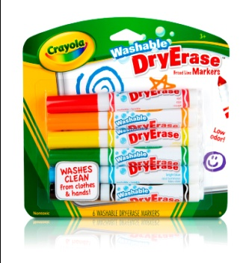With an increasing number of teachers using dry-erase boards in their classrooms, dry-erase writing tools are quickly becoming a back-to-school essential. Crayola has responded to the call of teachers and parents with the development of the only dry-erase creativity tools specifically for kids. Crayola’s new **Dry-Erase Washable Markers** let kids brighten up any subject with vibrant colors that pop and grab attention on dry-erase surfaces. The Dry-Erase Washable Markers have low odor and come in bright, bold colors that easily wipe off dry-erase surfaces so kids can create, erase and create again for continuous learning. Moms will also appreciate that the markers wash clean from hands and clothes. Dry-Erase Washable Markers come in an assortment of bright colors and are available in 6-ct. and 12-ct. varieties.

**SRP Age Availability** $4.99 5+ Sept. 2012

**Product**

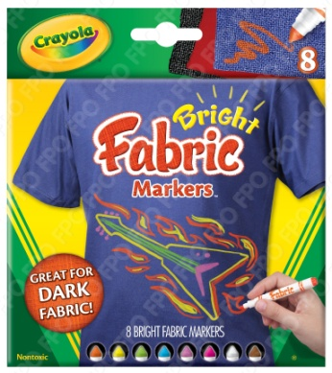With Crayola **Bright Fabric Markers**, kids can express themselves and customize their back-to-school fashions. Whether it’s showing off school spirit on a backpack orcreating wild, brightly colored designs on a new pair of jeans or a t-shirt, kids can bring out their creativity and self-expression. The bright colors will “pop” off dark fabrics, showing kids creations in a whole new light! The Bright Fabric Markers are available in 8 unique colors.

**SRP Age Availability** $4.99 3+ Now

**Product**

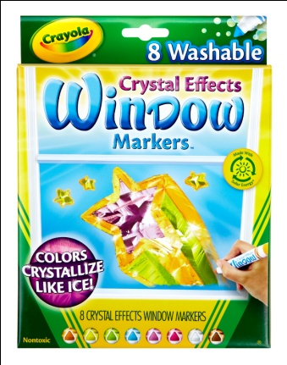With Crayola’s **Crystal Effects Window Markers**, kids can show off their school spirit and transform an ordinary window or mirror into a colorful crystal canvas! Kids can create amazing effects on windows that dry to bright, crystalized colors. Whether it’s creating a school mascot rendering or decorating the family minivan for the first big game of the season, kids can proudly display their school pride. The markers are fully washable from windows, fabric and skin, and the colors wipe off of windows with a damp cloth. The markers are available in 8 bright colors.

# # #